|  |  |
| --- | --- |
|  | *Code Inspection Report*  *‘Bom Dia Academia’ Software Development Project*  BSc/MSc in [LEI | LIGE | METI]  Academic Year 2018/2019 - 1º Semester  Software Engineering I  Group 99  73051, Diogo Juvandes, LIGE-PL  78475, João Alves, LIGE-PL  73528, Miguel Penedo, LIGE-PL  ISCTE-IUL, Instituto Universitário de Lisboa  1649-026 Lisbon  Portugal  December 2018 |

**Table of Contents**

Introduction 3

Code inspection – Name of the component being inspected 3

Code inspection checklist 3

Found defects 3

Corrective measures 3

Conclusions of the inspection process 3

# Introduction

*Description of the software being produced*

# Code inspection – Name of the component being inspected

*Description of the software component being inspected*

O Code Inspection foi realizado pelos membros do grupo.

|  |  |
| --- | --- |
| *Meeting date:*  *Meeting duration:*  *Moderator:*  *Producer:*  *Inspector:*  *Recorder:* | *07/12/2018*  *30 minutes* |
| *Component name (Package/Class/Method):* | *Source/Mainjava* |
| *Component was compiled:* | *Yes* |
| *Component was executed:* | *Yes* |
| *Component was tested without errors:* | *Yes* |
| *Testing coverage achieved:* | *Yes* |

# Code inspection checklist

# 

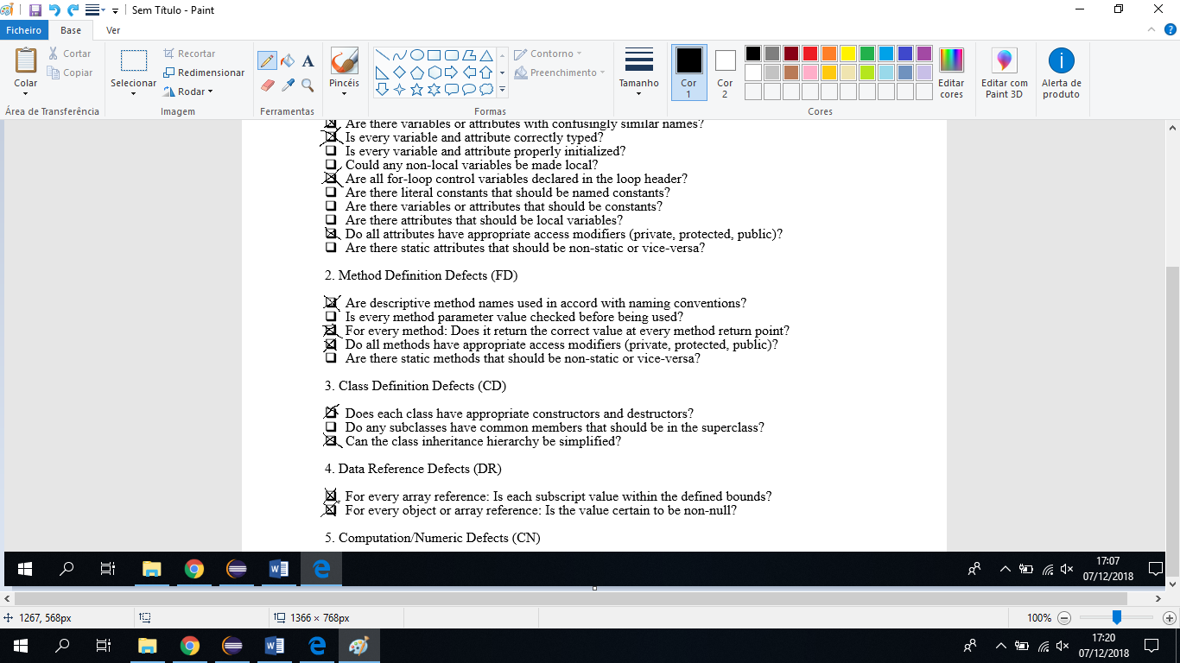

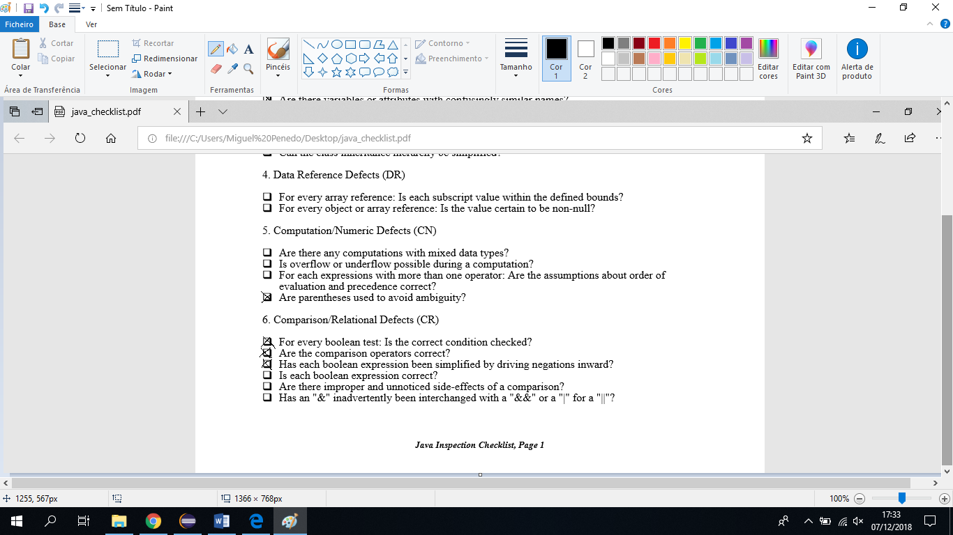

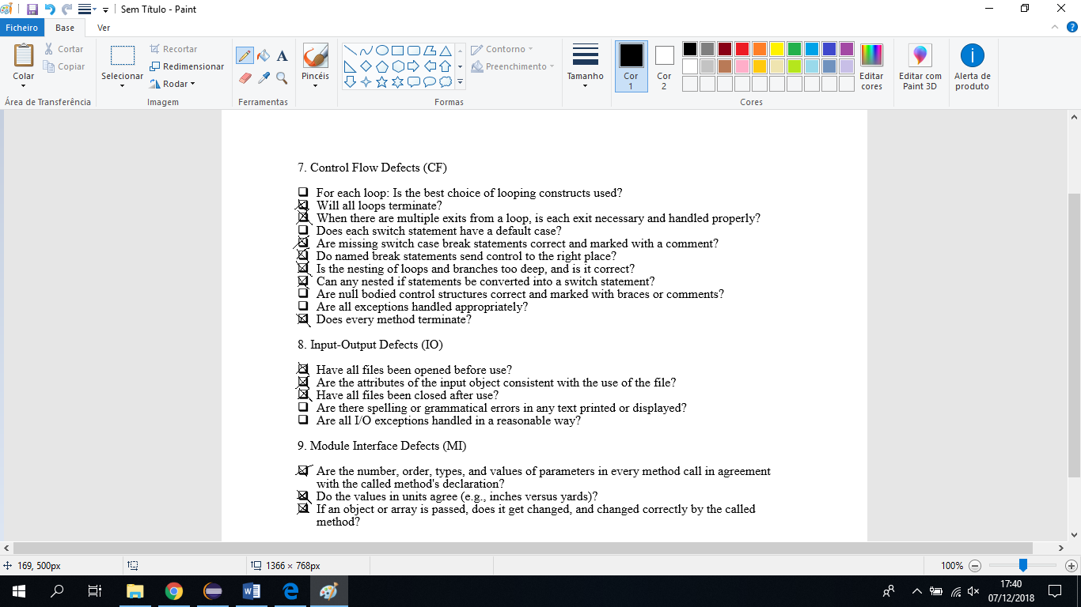

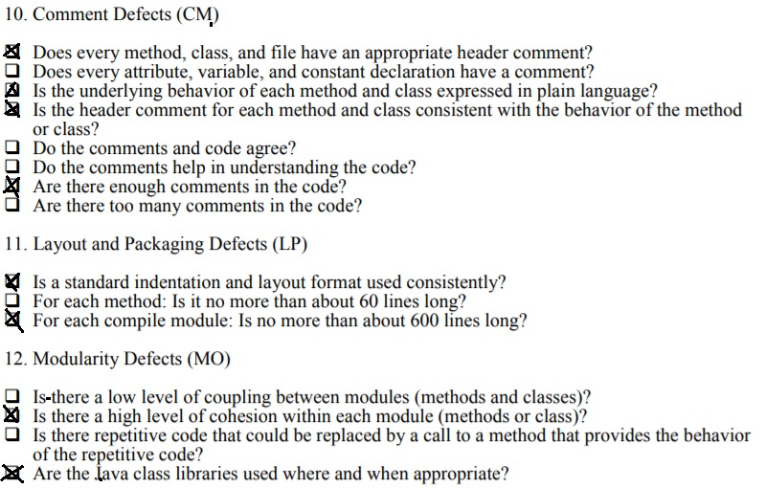

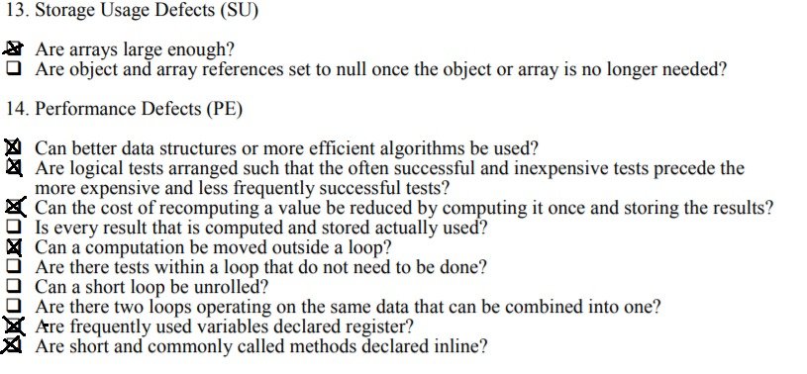

# Found defects

Identify and describe found defects, opinions and suggestions.

|  |  |  |  |
| --- | --- | --- | --- |
| **Found defect Id** | **Package, Class, Method, Line** | **Defect category** | **Description** |
| 1 |  |  |  |
| 2 |  |  |  |
| 3 |  |  |  |
| ... | ... | ... | ... |

# Corrective measures

*Found defect Id, how/when/who will correct the identified defect.*

# Conclusions of the inspection process

**Note: Each group may adapt the current template according to its needs and preferences or adopt a different template. Decisions on template adaptations or the use of a different template must be justified.**